**Task 1 : Split the author column in two and replace the resulting nulls with blanks.**

• Split the author column in two

Get data -> Transform data -> Select column -> Split column

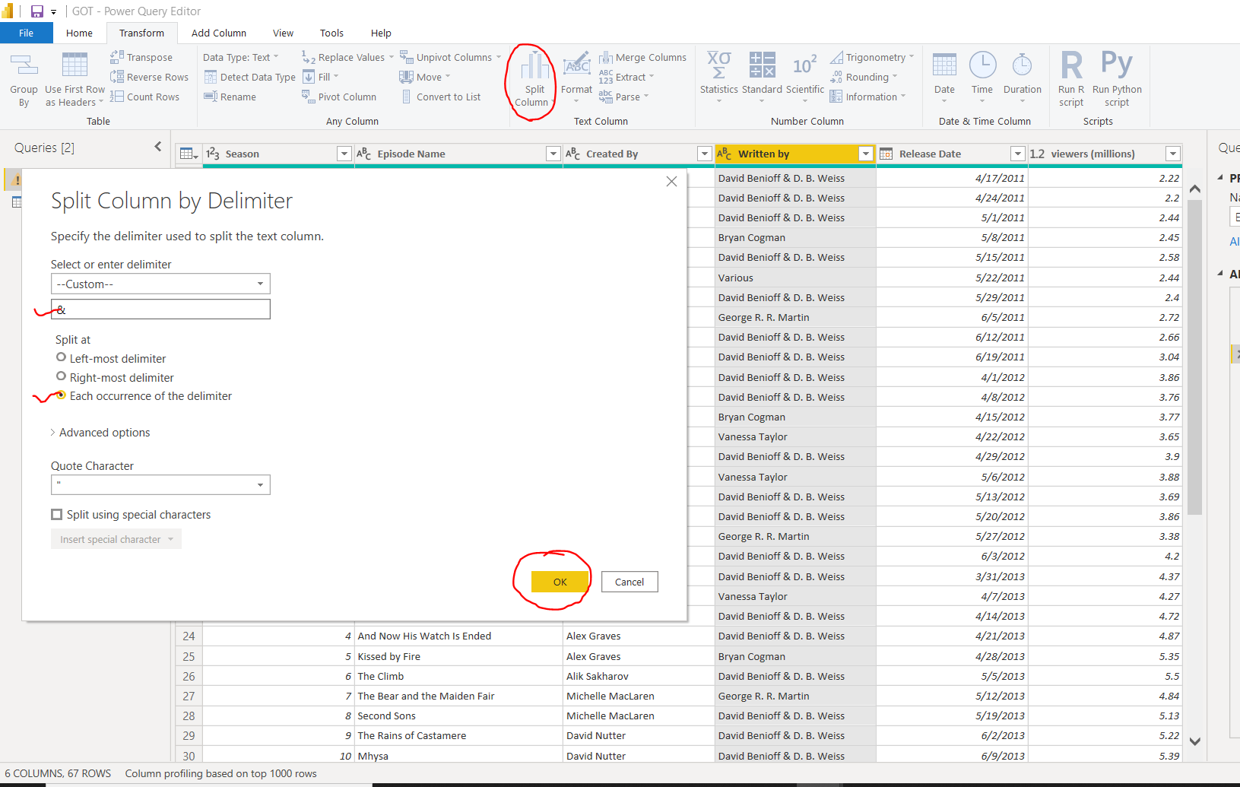

Then you get two different column. Left side of &delimiter in one column and remains part in another column  .

There is another method also,  select column -> right click  -> select split column. And remaining is same as above part.

• Replacing the resulting nulls with blanks.

Select column ->  Replace values

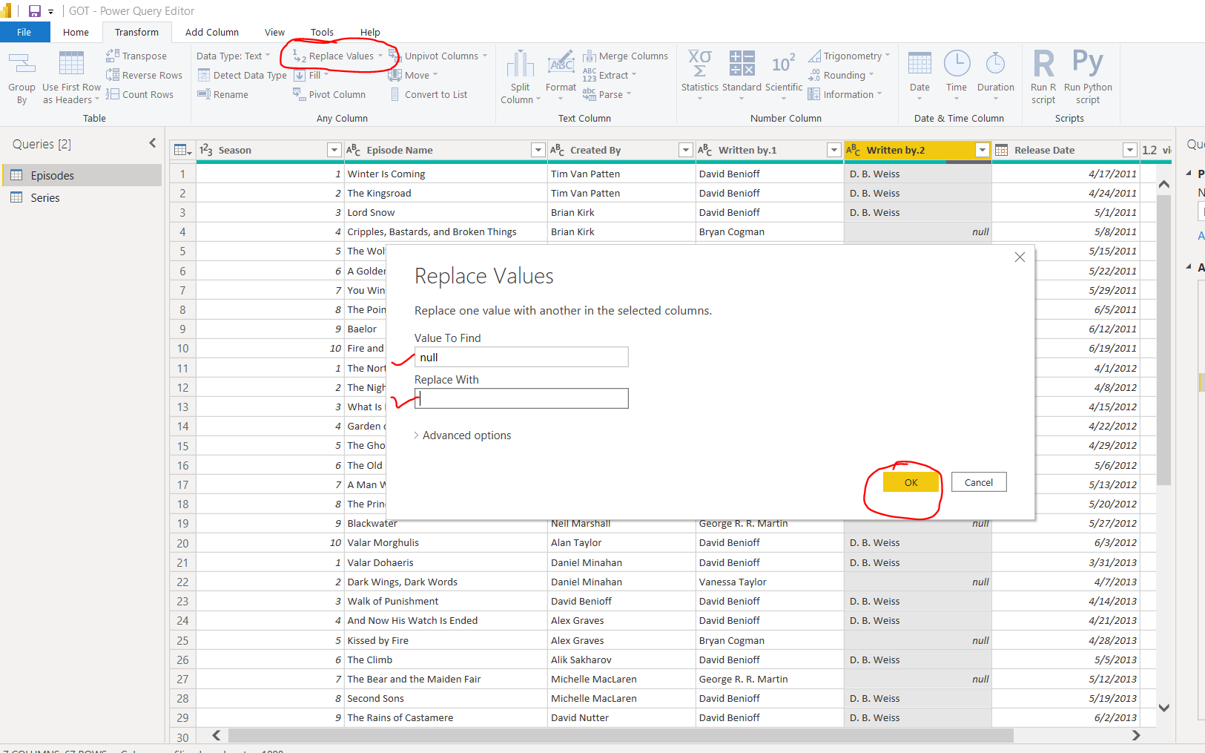

When we click on ok then null values are replace with blank.

There is another method also Select column -> right click -> Replace values

**Task 2 : The dates needs to be format as I am not happy they are appearing.**

Get data -> Transform data -> Close and Apply -> Select column -> Column Tool -> format

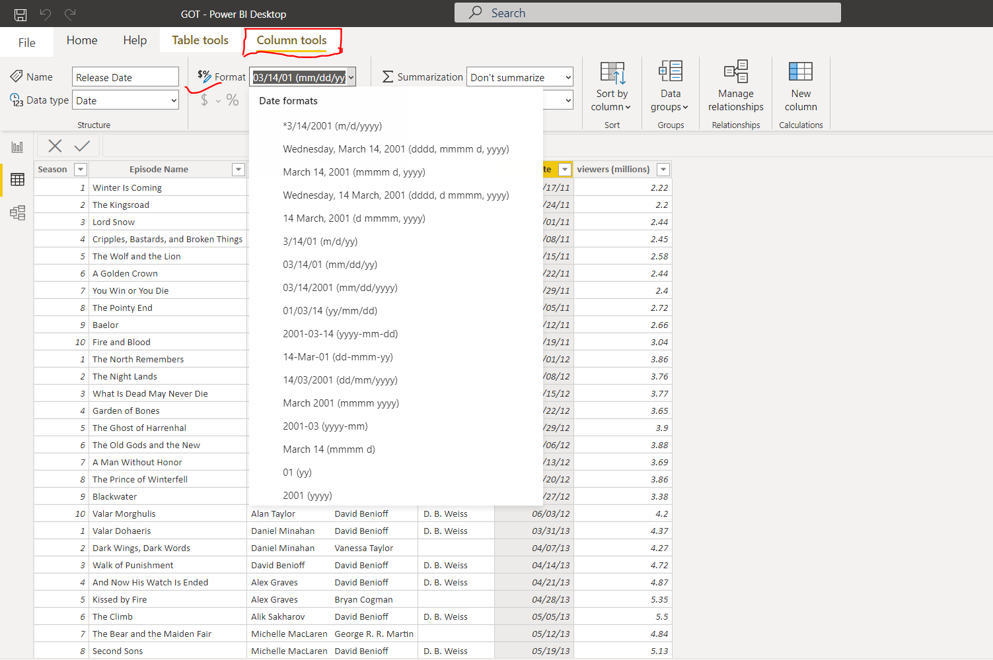

Click whatever format is suitable for data .

**Task 3 : You should also filter the data to show only episodes directed by Daniel.**

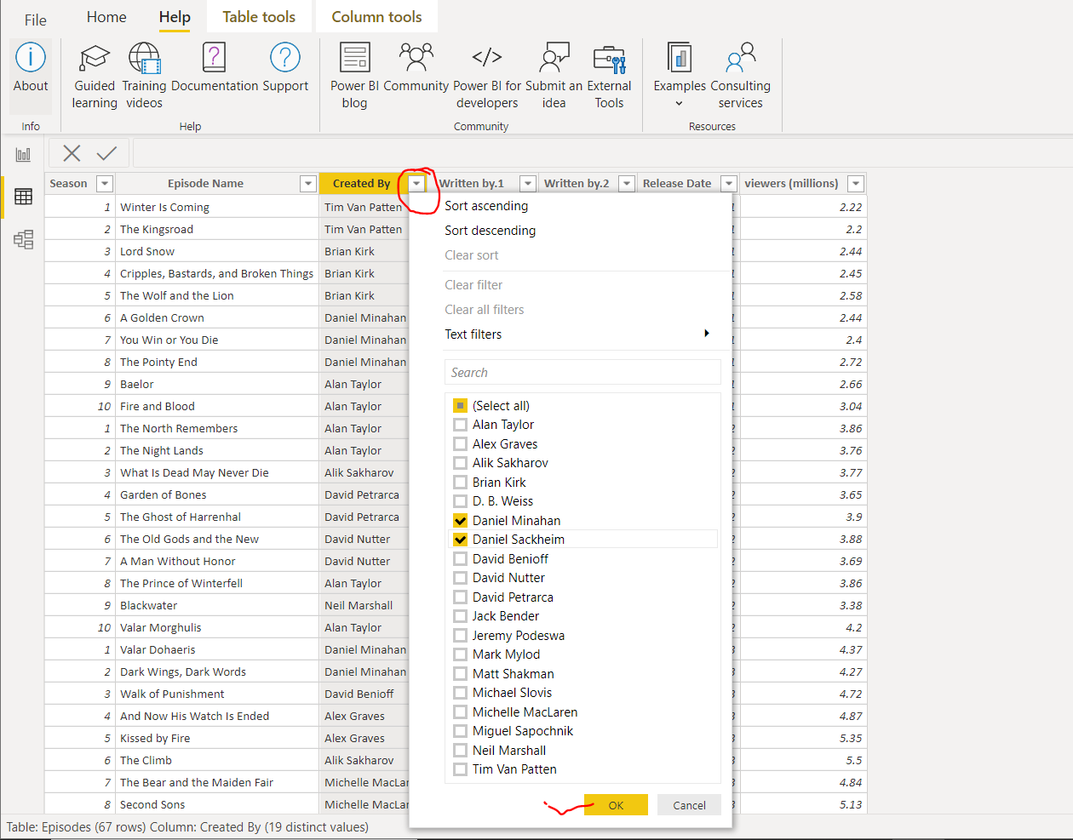

Then it select only Daniel all data in table.

**Task4 :  Should show how many people watched each episode Written by the various authors :               1)Episode Name  2) No. of viewers 3)Mostly watch Directors**

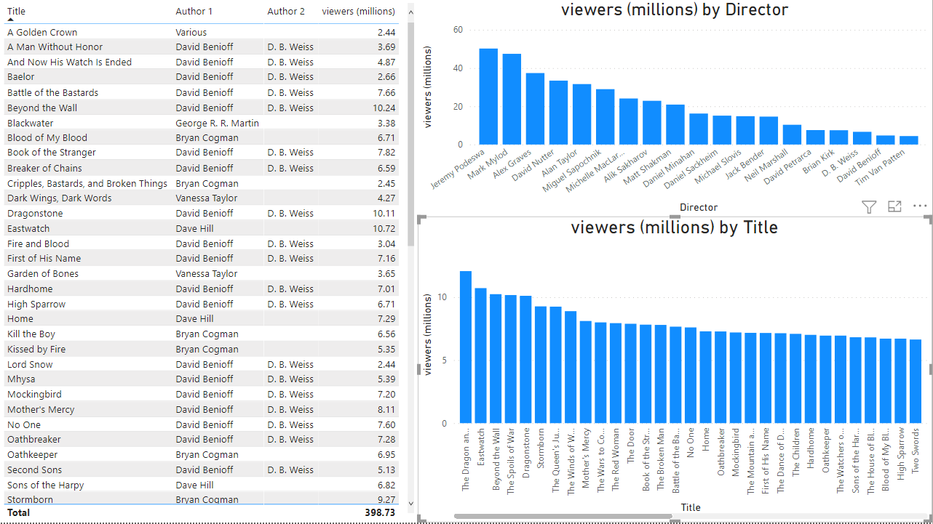

This is visualization of total data.

**Some Insight:**

1) A most watched Episode "A Golden Crown" has author Various and viewers count  2,44 millions 2) Jeremy Podeswa is a most famous Director In all of industry. He has directed films are "Home",

"The Dragon and the Wolf", "Dragonstone", "The Red Woman", "Unbowed", "Unbent",

"Unbroken Kill the Boy".

3)  The Total no of viewers are 398.73 millions

**Task 5 : Can you show me some interesting insights in terms of the release dates that will help me to have an idea about frequency of each episode coming up and help me to plan the future production.**

5. Go to File and select Close & Apply. To change the date format from DD-MM-YYYY one can go to Data view. Select Release date column & from column tools drop down select required format i.e. in text.

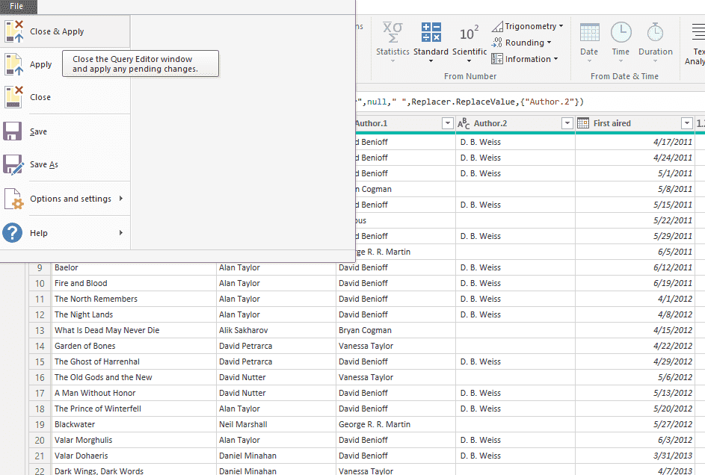

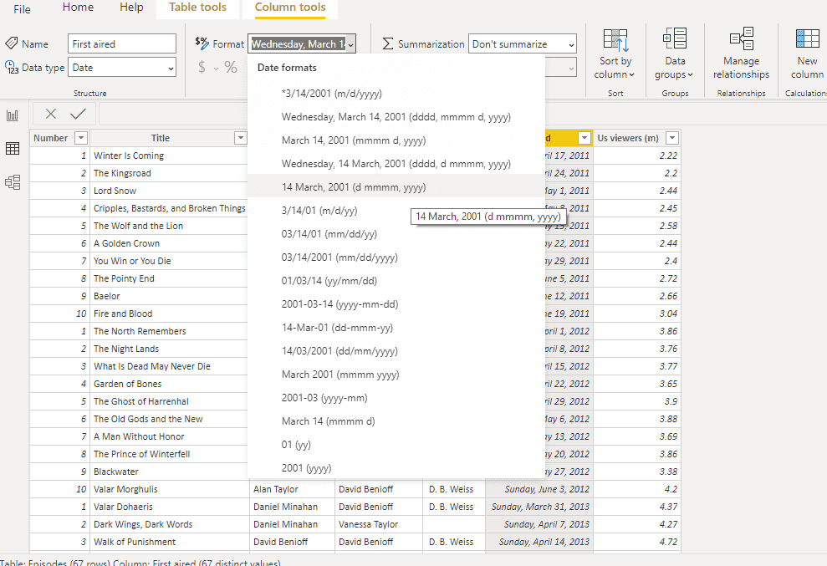

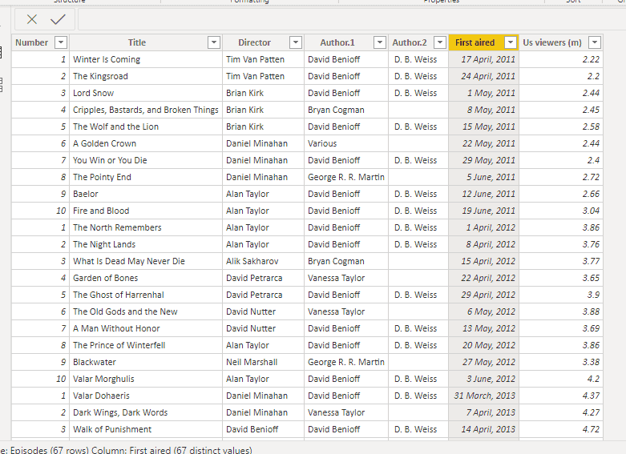

**Task6 -  For filtering the director i.e. Daniel Minahan, select the Director column & click on the drop down. For drop down un tick others & select Daniel Minahan. Click ok. Hence the desired filtered table is generated. One can perform same steps in POWER QUERY EDITOR also to generated the same filtered table.**

